Russian weekly grain, April 21-22, 2025
IKAR
Not for reproduction and redistribution. It is our policy that RWG and its parts are NOT distributed and NOT meant to ANY government body or agency. Thank you for your understanding and cooperation

Hot topics and headlines

Obviously, the nuances of peace talks immediately affect the dynamics of domestic stocks prices, ruble exchange rate fluctuations, etc. Most recent factual braking of peace deal movement immediately resulted in stocks and ruble decline…

“False alarm”: Russia prolongs its grain import and transshipment regime with Kazakhstan. Kazakhstan wheat, flax, and lentils are allowed only for direct transit to the foreign destinations (such as Azerbaijan and Baltic states ports), as well as direct wagon-vessel transshipment in the Russian ports (as we explained, the only Russian port which is able to make such operations is Novo, but its factual capacity is seen as no more than 30 tmt per month)...
***
We further elevate April wheat export level to 2.1-2.2 mmt.
***
FOB Black Sea 12.5% wheat price index is seen at $248 per ton, 11.5% is at $240 per ton. New 12.5% wheat crop is inverted, and currently seen at $233 per ton… Ceteris paribus,there are less than couple of months to adjust to new realities…
***
Black Sea CPT wheat export terminals prices are down, but we must check if it’s just one of multiple attempts, or really serious, and farmers start to retreat...

Of course, terminals lower fobbing rates, that now are more “individual” for exporters than normally…
***
Quite deep soil frosts are forecasted in the mornings of Sunday-Wednesday in spots of Western Russia and, surprisingly, and especially, across most of Ukraine... We will be able to estimate the outcomes by the end of next week…
***

Hot topic 1. Export pace. We further elevate April wheat export level to 2.1-2.2 mmt.

Rus grain export shipments accrdng to ports and railway data,tmt
 | Wheat |  |  |  |  | Barley |  |  |  |  | Corn |  |  |  |  | All grains+pulses
 | 2022/ 23 | 2023/24 | 2024/25 |  |  | 2022/ 23 | 2023/24 | 2024/25 |  |  | 2022/ 23 | 2023/24 | 2024/25 |  |  | 2022/ 23 | 2023/24 | 2024/25
 |  |  | Ports | In-land | Total |  |  | Ports | In-land | Total |  |  | Ports | In-land | Total |  |  | Ports | In-land | Total
July* | 2209 | 4133 | 3190 | 460 | 3650 | 262 | 1201 | 918 | 83 | 1001 | 247 | 547 | 321 | 4 | 325 | 2802 | 6166 | 4573 | 581 | 5155
August | 3769 | 5367 | 5162 | 401 | 5563 | 804 | 1177 | 546 | 45 | 592 | 141 | 276 | 273 | 3 | 276 | 4870 | 7162 | 6112 | 489 | 6601
September | 4138 | 5345 | 5001 | 440 | 5442 | 701 | 999 | 617 | 88 | 706 | 40 | 281 | 232 | 2 | 235 | 5145 | 7508 | 6108 | 596 | 6704
October | 4719 | 5049 | 5389 | 457 | 5846 | 626 | 545 | 496 | 99 | 595 | 91 | 595 | 344 | 1 | 344 | 5666 | 6729 | 6683 | 646 | 7329
November | 4804 | 3397 | 4019 | 442 | 4461 | 581 | 395 | 322 | 75 | 397 | 232 | 640 | 388 | 2 | 389 | 5802 | 4792 | 4936 | 573 | 5509
December | 4477 | 3865 | 3628 | 251 | 3879 | 371 | 363 | 129 | 51 | 180 | 467 | 591 | 326 | 32 | 358 | 5496 | 5282 | 4234 | 382 | 4616
January | 4161 | 3938 | 2390 | 86 | 2476 | 241 | 434 | 340 | 79 | 419 | 669 | 835 | 368 | 60 | 428 | 5194 | 5590 | 3336 | 255 | 3591
February | 3251 | 4251 | 1832 | 98 | 1930 | 289 | 456 | 172 | 84 | 256 | 631 | 843 | 204 | 29 | 233 | 4337 | 5894 | 2354 | 232 | 2587
March | 4724 | 4646 | 1727 | 112 | 1839 | 325 | 450 | 0 | 34 | 34 | 948 | 790 | 0 | 0 | 0 | 6280 | 6304 | 1812 | 210 | 2022
April 1-22 | 4349 | 4929 | 1464 | 70 | 1534 | 439 | 977 | 12 | 13 | 25 | 895 | 651 | 37 | 0 | 37 | 5943 | 6907 | 1563 | 119 | 1682
May | 4250 | 4660 | 0 | 0 | 0 | 490 | 724 | 0 | 0 | 0 | 634 | 615 | 0 | 0 | 0 | 5706 | 6343 | 0 | 0 | 0
June | 3678 | 4580 | 0 | 0 | 0 | 412 | 591 | 0 | 0 | 0 | 483 | 514 | 0 | 0 | 0 | 4949 | 5889 | 0 | 0 | 0
Total | 48529 | 54161 | 33802 | 2817 | 36620 | 5541 | 8312 | 3553 | 651 | 4204 | 5476 | 7178 | 2493 | 133 | 2626 | 62191 | 74566 | 41713 | 4084 | 45796
April 1-22 | 3084 | 3553 | 1464 | 70 | 1534 | 304 | 712 | 12 | 13 | 25 | 648 | 515 | 37 | 0 | 37 | 4221 | 4989 | 1563 | 119 | 1682
01.07-22.04 | 39336 | 43546 | 33802 | 2817 | 36620 | 4504 | 6731 | 3553 | 651 | 4204 | 4112 | 5912 | 2493 | 133 | 2626 | 49814 | 60416 | 41713 | 4084 | 45796

Hot topic 2. April 1-22 key Russian grains export country break-down, tmt (incl.April 1-15 railway data).
All grains | 1 631 |  | Wheat | 1 534 |  | Barley | 25 |  | Corn | 37
TURKIYE | 255 |  | TURKIYE | 255 |  | LEBANON | 12 |  | CHINA | 24
IRAN | 206 |  | IRAN | 204 |  | KAZAKHSTAN | 6 |  | S KOREA | 10
EGYPT | 131 |  | EGYPT | 131 |  | BELARUS | 5 |  | JAPAN | 3
S ARABIA | 127 |  | S ARABIA | 127 |  | IRAN | 2
ISRAEL | 114 |  | ISRAEL | 114 |  | TADJIKISTAN | 0,3
LIBYA | 108 |  | LIBYA | 108
NIGERIA | 77 |  | NIGERIA | 77
OMAN | 72 |  | OMAN | 72
SUDAN | 66 |  | SUDAN | 66
N/A | 61 |  | N/A | 59
TUNISIA | 56 |  | TUNISIA | 56
TANZANIA | 54 |  | TANZANIA | 54
CHINA | 50 |  | SENEGAL | 33
KAZAKHSTAN | 35 |  | MOROCCO | 32
LEBANON | 33 |  | KAZAKHSTAN | 29
SENEGAL | 33 |  | YEMEN | 24
MOROCCO | 32 |  | ALBANIA | 24
YEMEN | 24 |  | LEBANON | 21
ALBANIA | 24 |  | GEORGIA | 17
GEORGIA | 17 |  | BELARUS | 8
S KOREA | 15 |  | UZBEKISTAN | 7
BELARUS | 12 |  | TADJIKISTAN | 7
TADJIKISTAN | 7 |  | KYRGYZSTAN | 6
UZBEKISTAN | 7 |  | SERBIA | 3
KYRGYZSTAN | 6 |  | AZERBAIJAN | 1
SERBIA | 3 |  | AFGHANISTAN | 1
JAPAN | 3 |  | ESTONIA | 1
AZERBAIJAN | 1 |  | MONGOLIA | 0,04
AFGHANISTAN | 1
ESTONIA | 1
LITHUANIA | 0,4
MONGOLIA | 0,3

Hot topic 3. Official ruble exchange rate is down to both dollar and euro, obviously, due to lack of geopolitical progress…
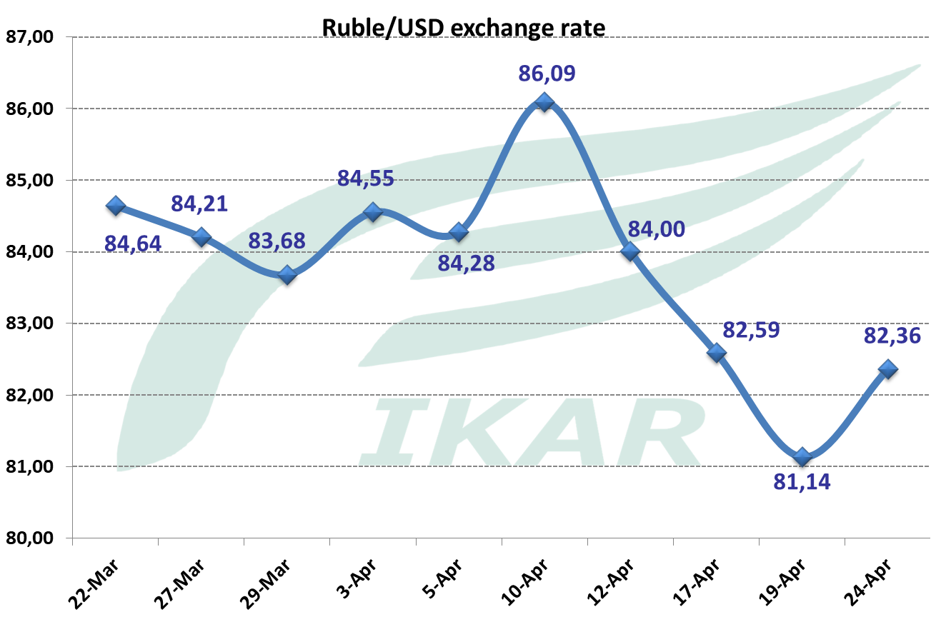

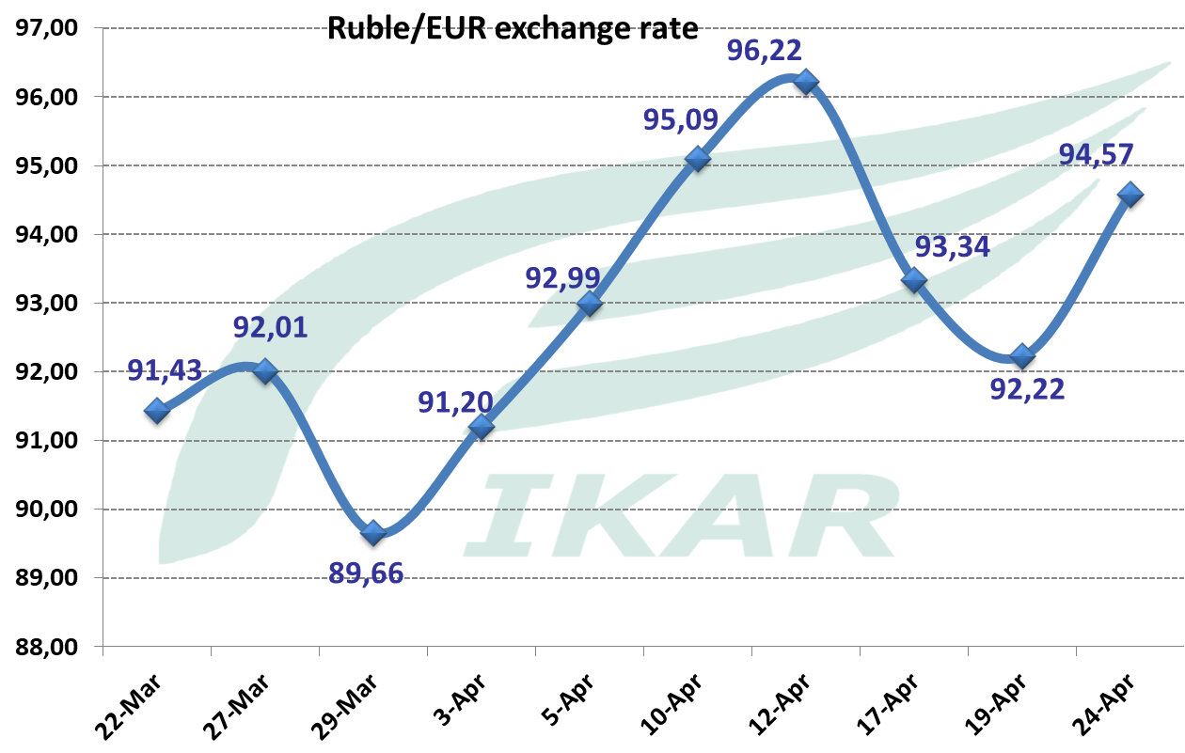

Hot topic 4. Our FOB Black Sea 12.5% wheat price index remains at $248 per ton of 12.5% wheat, and $240 per ton of 11.5% wheat.

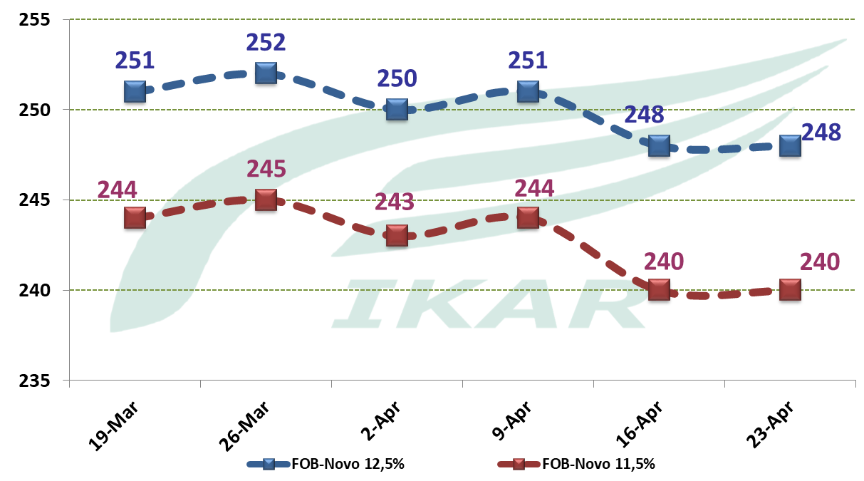

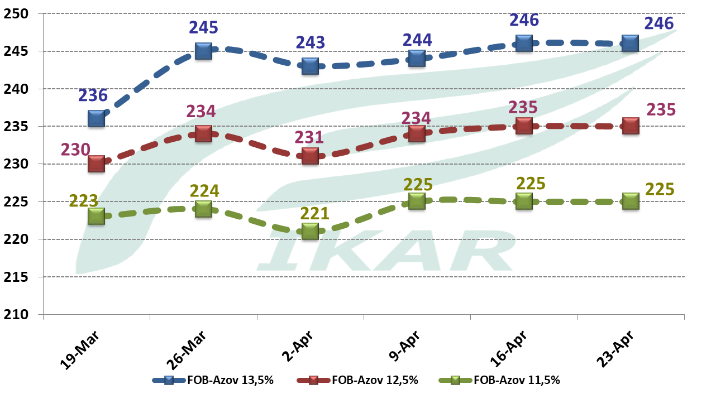

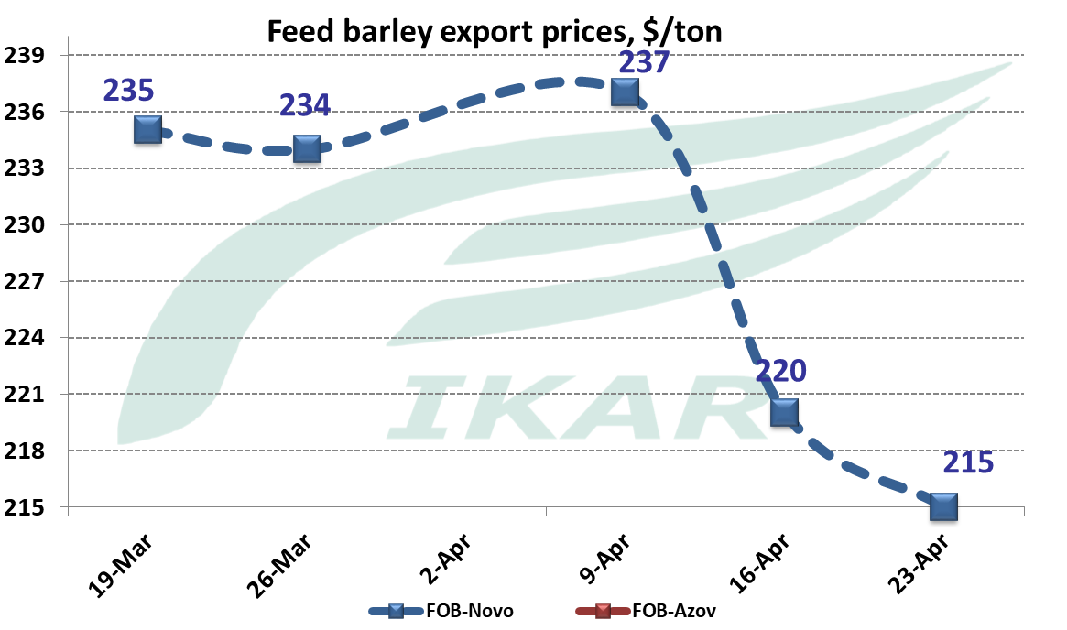

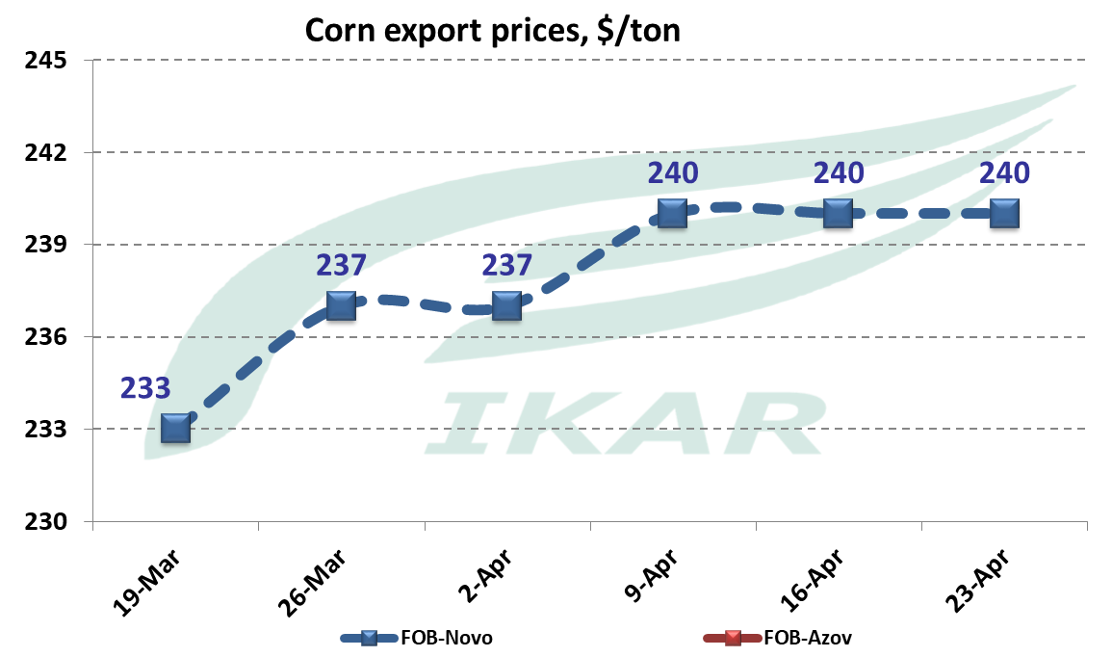

New crop 12.5% is now seen at $233 but we don’t see any transactions with the Russian wheat.

Liquidity in the ports remains very minimal. CPT Novo 12.5% export terminal prices are now about RUR17400in comparison with 17800 aweek ago, but, again, this level must be tested. If to deploy RUR17400 as an equilibrium, for non-bound company it provides $250 as a current FOB cost equivalent, w/o cost of finance...

New crop Rus Black Sea 12.5% is, reportedly is priced at $233 per ton. Of course, there are no fixing yet.

Azov Sea values are, as usual, difficult to determine, as the purchase price variability is too high. Our 12.5% price index for those who are in need, remains near RUR16800, amid very thin market. For non-bound company it provides about $232 Azov Sea, and the same $250 as Port Kavkaz FOB cost equivalent.

FOB Black, Azov, Caspian Seas, and factual CPT export terminals exporters prices, VAT inclusive*
 | FOB, $/ton |  |  | CPT export terminals, RUR/ton
 | April 23 | April 16 |  | April 23 | April 16

10.5%
11.5% | 240 | 240 |  | 19450 | 19450
12.5% | 248 | 248 |  | 19690 | 19690
13.5% | 256 | 256 |  | 20000 | 20000

14.5%
New crop 12.5% | 233 | 223/235
Feed barley | 234 nominal | 234 nominal |  | na | na
Corn | 237 nominal | 237 nominal |  | na | na
Azov Sea |  |  |  |  |  |  |  |  |  | 13860-13970
Azov – Marmara freight rate | 19 | 20
Feed wheat |  |  |  | 16200 | 16200
10.5% | na | na |  | 17100 | 17100
11.5% | 225 | 225 |  | 17640 | 17640
12.5% | 235 | 235 |  | 18480 | 18480
13.5% | 246 | 246 |  | 19020 | 19020
14.5% | 256 | 256 |  | 19660 | 19660
15.3% |  |  |  | 20160 | 20160
Feed barley | na | na |  | na | na
Corn | na | na |  | na | na
Peas, food, Azov | 290-295 | 285-290 |  | 23650-24200 | 23650-24200
Peas, food Novo |  |  |  | 27000-27500 no containers | 27000-27500 no containers
Chick pea  below 8 mm | 530-540 | 530-540
Lentils red | 525-530 nominal | 525-530 nominal
Lentils green | na | na
Wheat bran | 185 | 185

Caspian Sea, FOB Makhachkala/Astrakhan
Astrakhan/Aktau-N.Iran ports freight rates | 21/15 | 21/15
Barley Aktau | 230-235 | 232-235 |  | na | na

